**DAILY ONLINE ACTIVITIES SUMMARY**

|  |  |  |  |  |  |  |  |  |
| --- | --- | --- | --- | --- | --- | --- | --- | --- |
| **Date:** | **16-06-2020** | | | | | **Name:** | **D Jasmine Joyline** | |
| **Sem & Sec** | **VI Sem A** | | | | | **USN:** | **4AL17CS024** | |
| **Online Test Summary** | | | | | | | | |
| **Subject** | | **Python Workshop Test** | | | | | | |
| **Max. Marks** | | **20** | | **Score** | | | **13** | |
| **Certification Course Summary** | | | | | | | | |
| **Course** | 1.Pre-Placement Training2.DA and ML workshop | | | | | | | |
| **Certificate Provider** | | | **-** | | **Duration** | | | **4hr** |
| **Coding Challenges** | | | | | | | | |
| **Problem Statement:**   1. Write a Java program to check whether a given a binary tree is a valid binary search tree (BST) or not? | | | | | | | | |
| **Status:Completed** | | | | | | | | |
| **Uploaded the report in Github** | | | | | **Yes** | | | |
| **If yes Repository name** | | | | | <https://github.com/alvas-education-foundation/D_Jasmine_Joyline/tree/master/daily_progress> | | | |
| **Uploaded the report in slack** | | | | | **Yes** | | | |

Online Test Details:

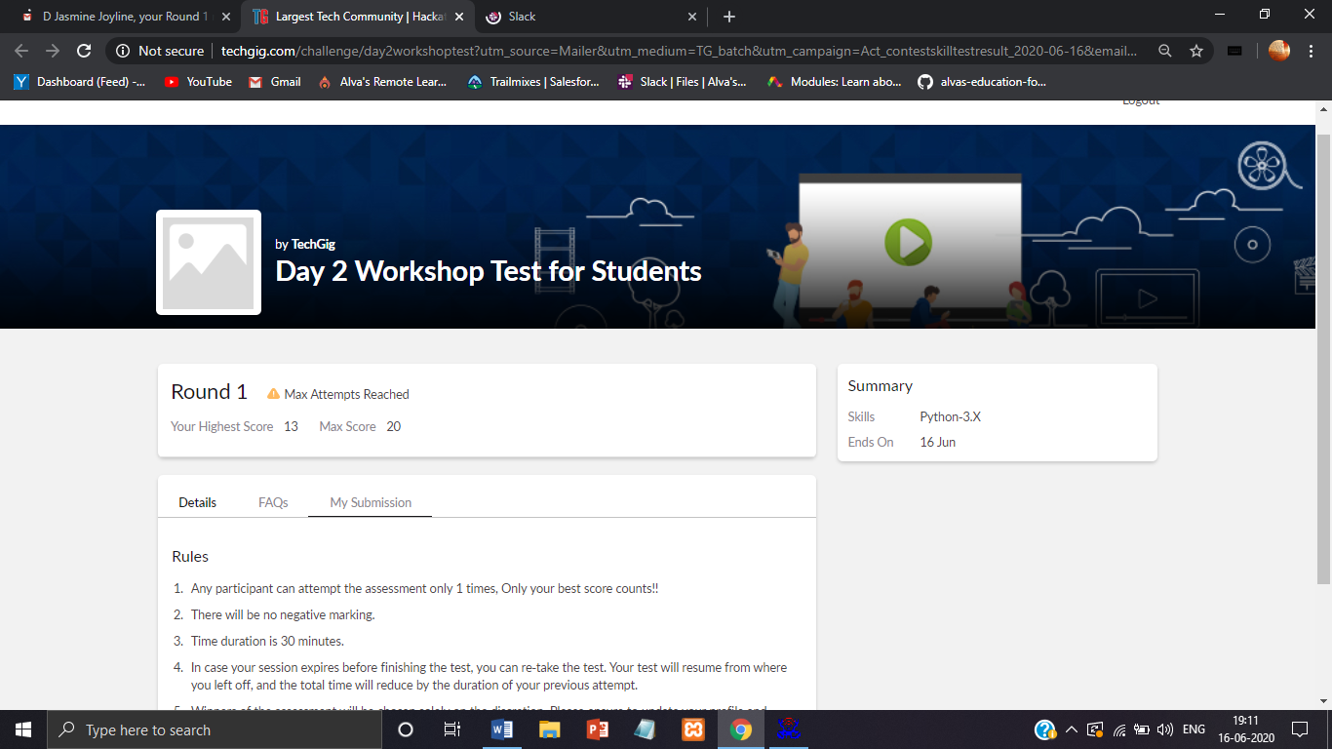

Online Training Details:

Attended class on the topic Programming in C. [from 9am to 11am]

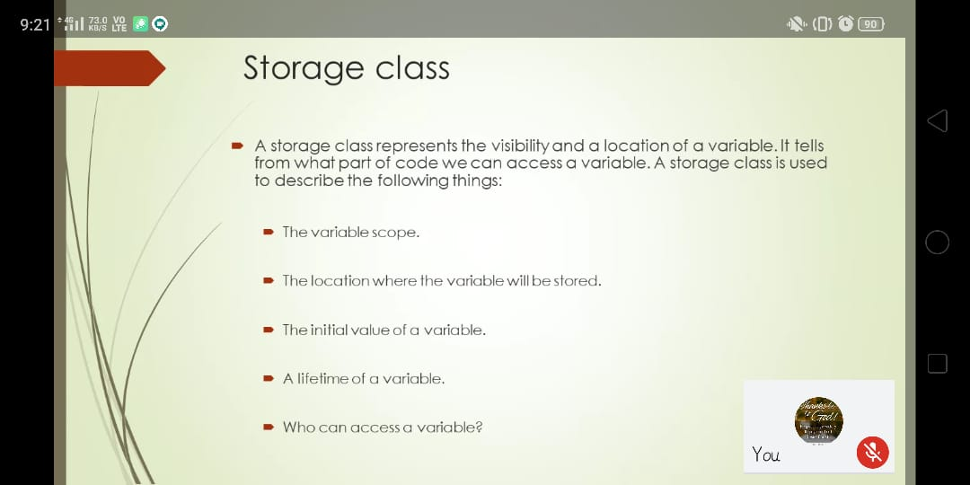

Attended Python Workshop on DA and ML. [from 11am to 1:30pm]

Worked out Python programs using Google Collab.

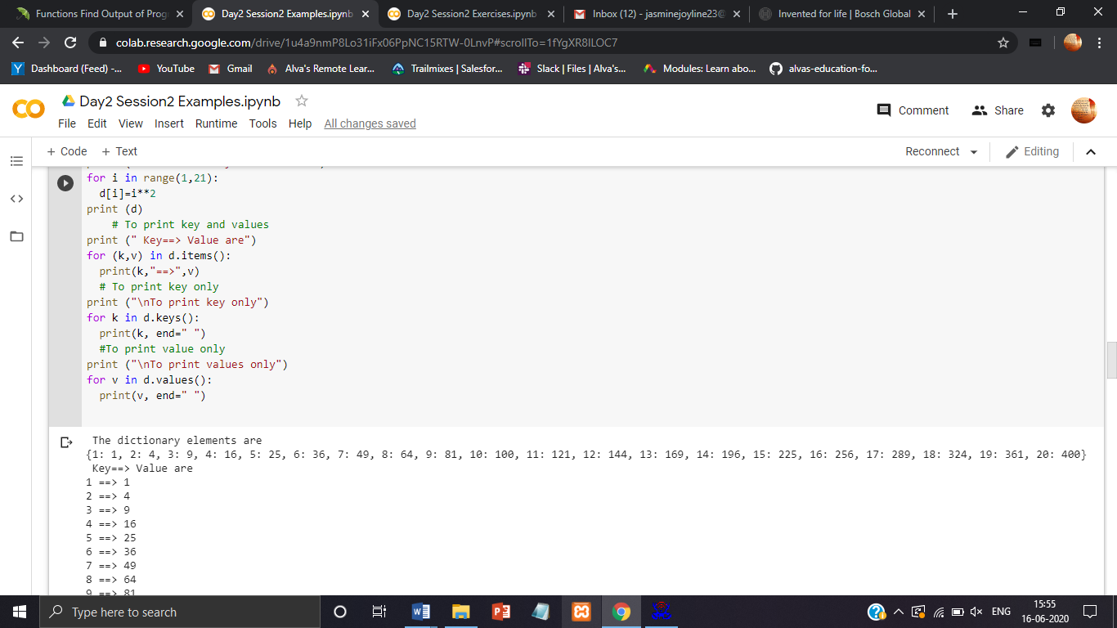

Coding Challenges Details:

1. Write a Java program to check whether a given a binary tree is a valid binary search tree (BST) or not?

